

**12 Common Pattern Printing Using C/C++**

**(Revise the Beginner Sheet 🧾)**

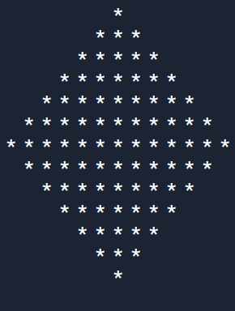

**Written By**

**Muhammad Anisuzzaman**

**ID: 191-16-403**

**Department: Computing and Information System**

* **Pattern 01: Print Right Triangle Star/Number Pattern**

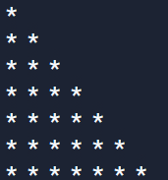

* **Note:** When we solve any Pattern Printing Problem, first we have to think about Rows and Columns such as in each row how many columns we have to print and find the relation between them. Then we can easily solve it. **In this problem,** we see that the row number and the column number are increasing simultaneously. So, the column depends on the row…🙄

**C++ Code: 😃**

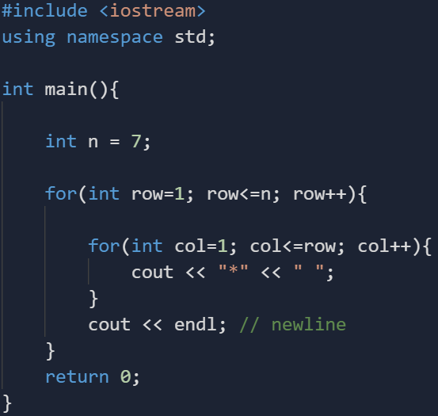

* 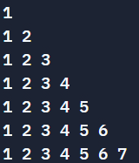If you print **column** value instead of **“*”**, it will print…

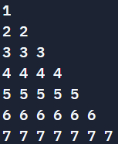

* If you print **row** value instead of **“*”**, it will print…
* 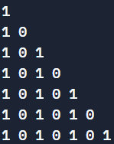If you print **col%2** value instead of **“*”**, it will print…
* 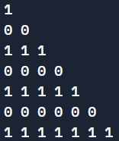If you print **row%2** value instead of **“*”**, it will print…
* **Think about this pattern How to print? 😋**

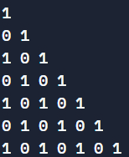

**C++ Code: 😮**

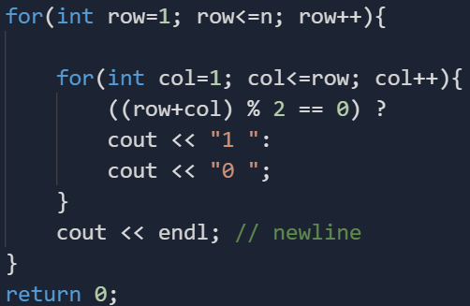

* **Note:** I use **ternary** **operator** because it is handy but you can use **if-else** instead of that…
* Think about **Floyd’s Triangle** How to print? **🙄**

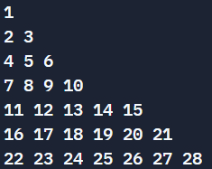

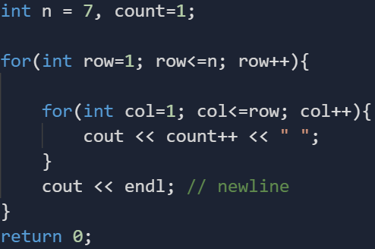**C++ Code: 😁**

* If you print **(char)(col+64)** value instead of **“*”**, it will print…

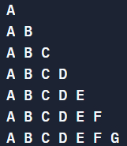

* If you print **(char)(row+64)** value instead of **“*”**, it will print…

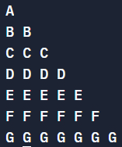

* **Note:** So, we see that, when we need **different** values, we print **column** value and when we need the **same** value, we print **row** value.
* **Pattern 02: Print Square Star Pattern**

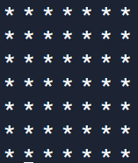

**C++ Code: 😑**

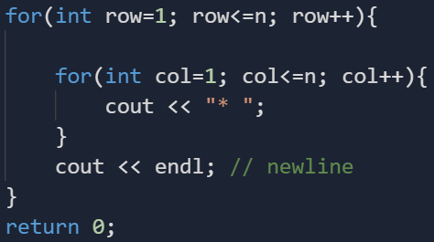

* **Pattern 03: Print Hollow Square Star Pattern**

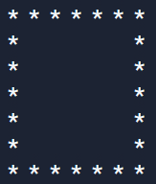

**C++ Code: 😎**

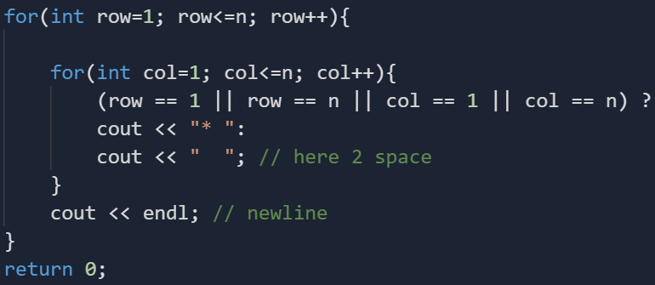

* 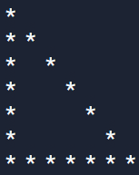**Pattern 04: Print Hollow Triangle Star Pattern**

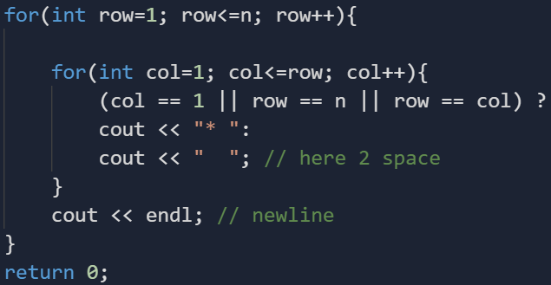**C++ Code: 🤨**

* 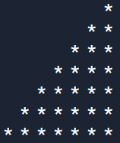**Pattern 05: Print Mirror Right Triangle Star Pattern**

**C++ Code: 🤐**

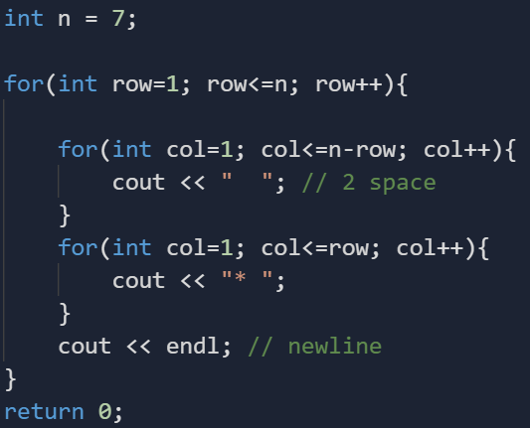

* 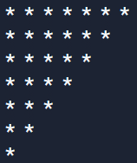**Pattern 06: Print Inverted Right Triangle Star Pattern**

**C++ Code: 🙃**

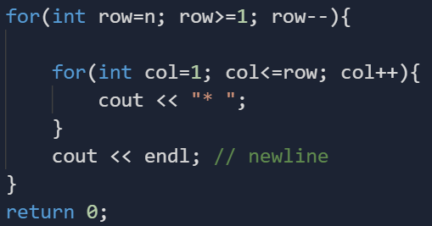

* 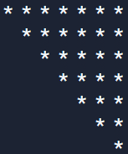**Pattern 07: Print Inverted Mirror Right Triangle Star Pattern**

**C++ Code: 🤪**

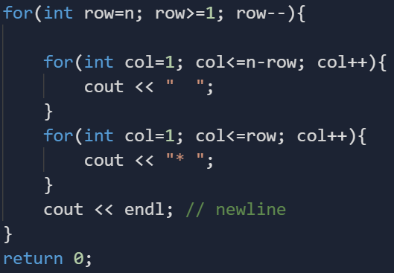

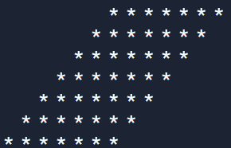**Pattern 08: Print Rhombus Star Pattern**

**C++ Code: 😕**

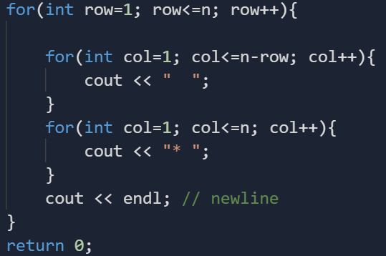

**Pattern 09: Print Pyramid Star Pattern**

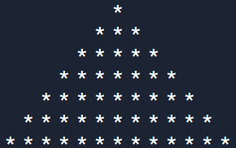

**C++ Code: 😲**

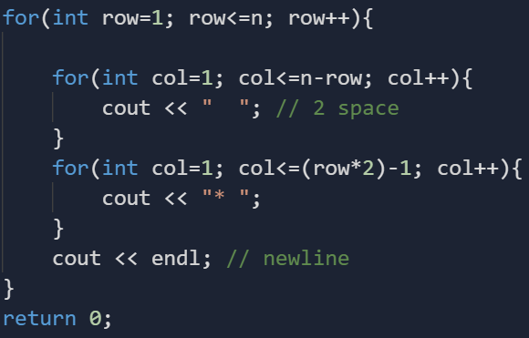

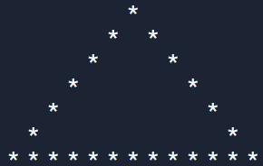**Pattern 10: Print Hollow Pyramid Star Pattern**

**C++ Code: 😶**

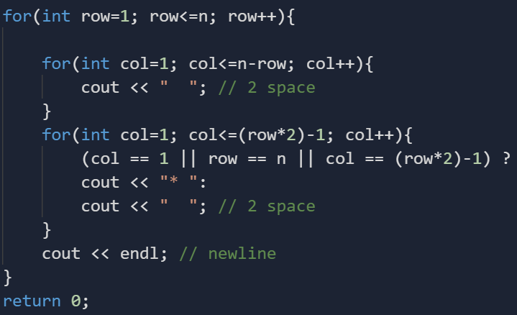

**Pattern 11: Print Diamond Star Pattern**



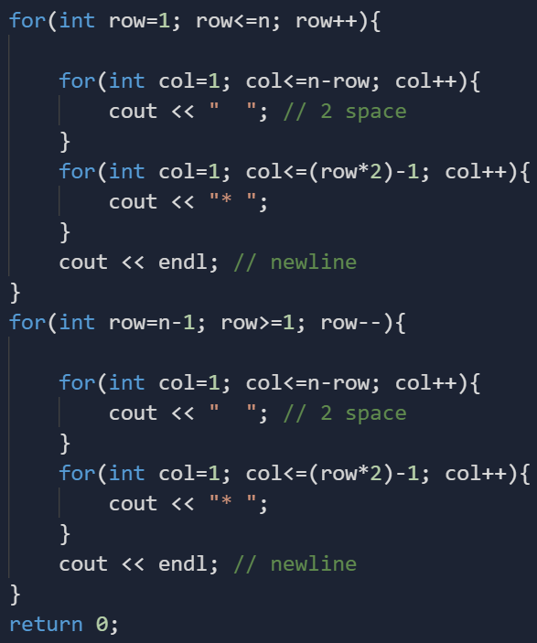**C++ Code: 🤯**

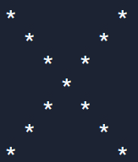**Pattern 12: Print Cross X Star Pattern**

**C++ Code: 🤑**

